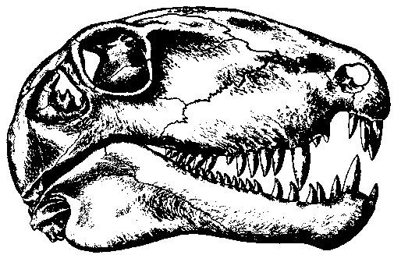 INTRODUCTION TO PALEONTOLOGY
Spring Quarter 2005

Geological Sciences 501 Instructor: Dr. L. E. Babcock
Lecture: 1:30-2:18 p.m., MTWR Office: 311 Mendenhall Laboratory
174 Mendenhall Lab Office hours: 12:30-1:30 MW
Laboratory: 1:30-3:18 p.m., F or by appointment
80 Orton Hall Phone: 292-0358
E-mail: babcock.5@osu.edu

Textbooks: Prothero, D. R., 2004. Bringing Fossils to Life, Second Edition. McGraw-Hill.
Feldmann, R. M. (editor). 1996. Fossils of Ohio. Ohio Division of Geological Survey.

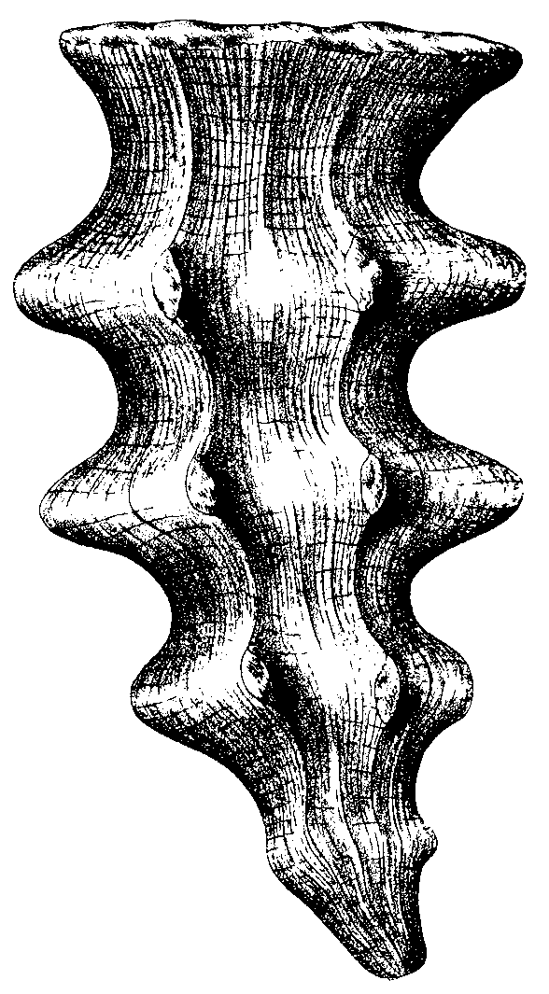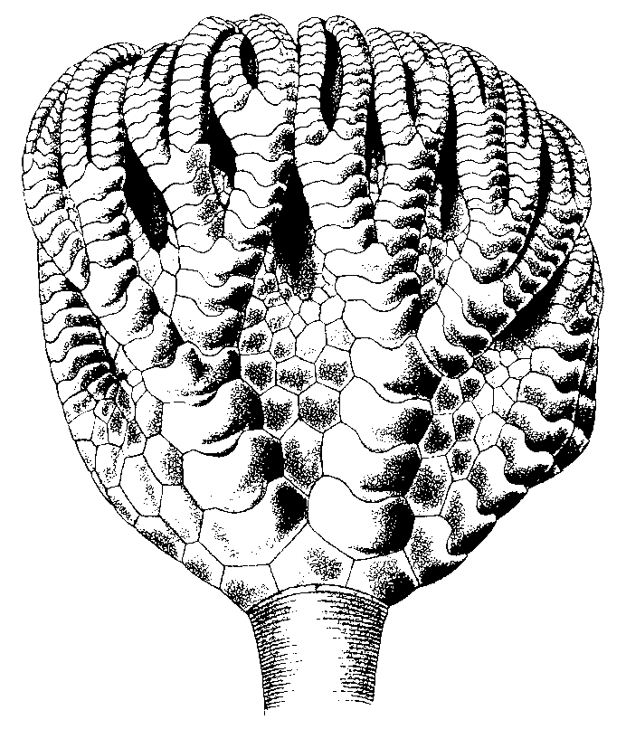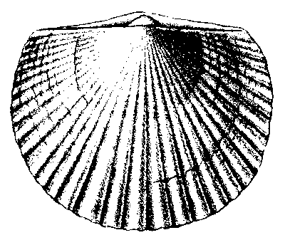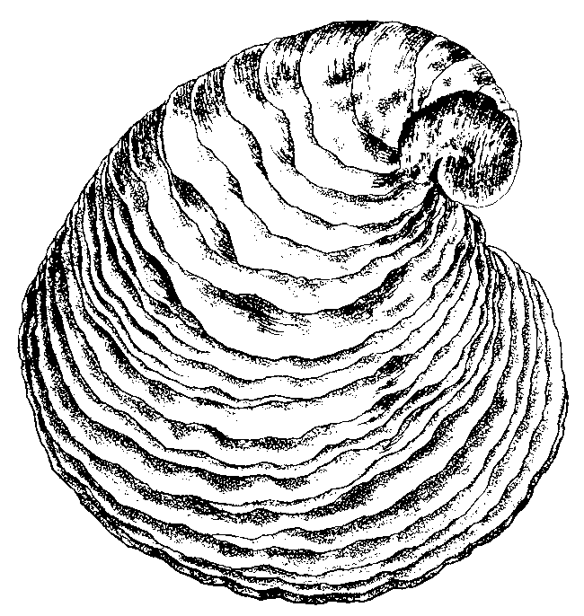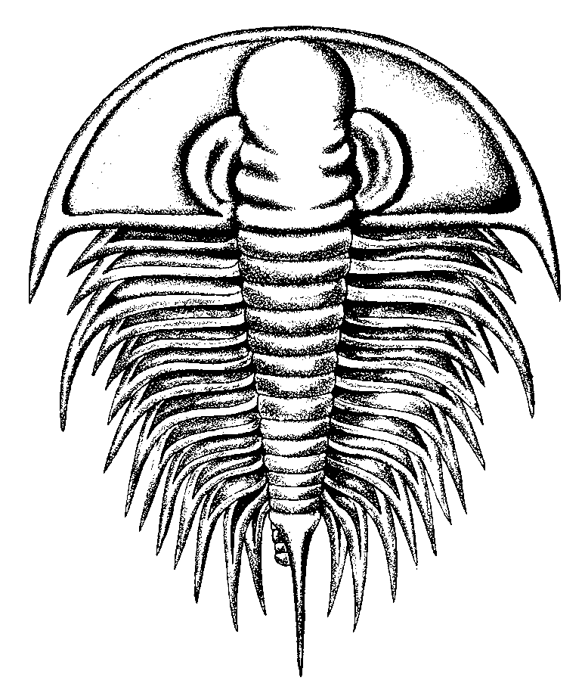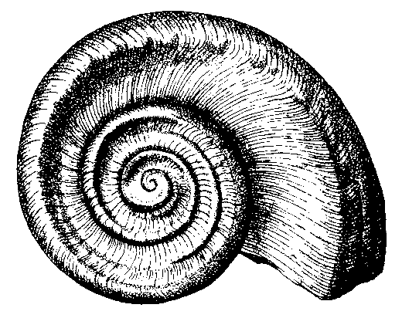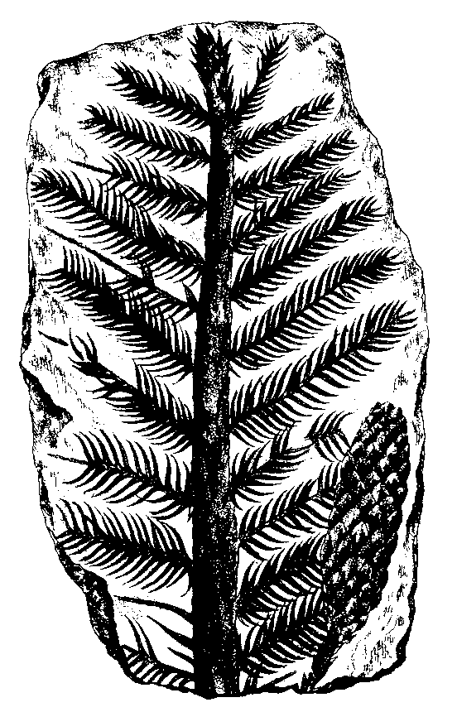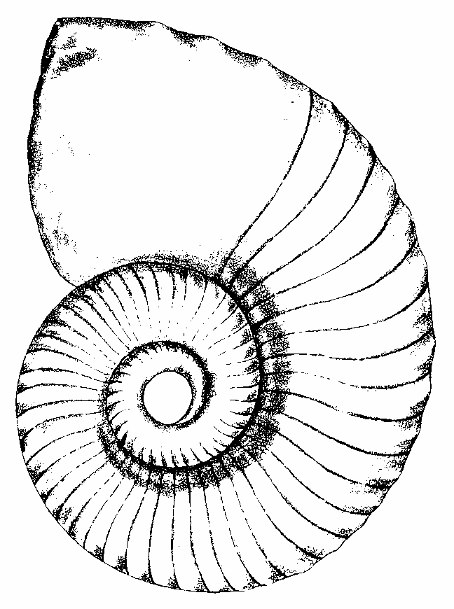

DATES TOPICS AND READINGS (Subject to change)

Mar.28- Introduction. Fossils and Earth history: principles of paleontology.
Apr. 1 · [Prothero, Ch. 1-6, 8-10; Feldmann, Ch. 1.]
LAB 1: Fossil preservation.

Apr. 4-8 Principles of paleontology (continued).
Microfossils, bacteria, and marine plants.
· [Prothero, Ch. 11; Feldmann, Ch. 22.]
LAB 2: Microfossils, bacteria, and marine plants.

Apr. 11-15 Sponges and cnidarians.
· [Prothero, Ch. 12; Feldmann, Ch. 4-7.]
LAB 3: Sponges and cnidarians.

Apr. 18-22 Brachiopods and bryozoans.
· [Prothero, Ch. 13; Feldmann, Ch. 15-16.]
LAB 4: Brachiopods and bryozoans.

Apr. 25-29 Mollusks.
· [Prothero, Ch. 15; Feldmann, Ch. 11-14.]
LAB 5: Mollusks.

May 2 EXAM 1

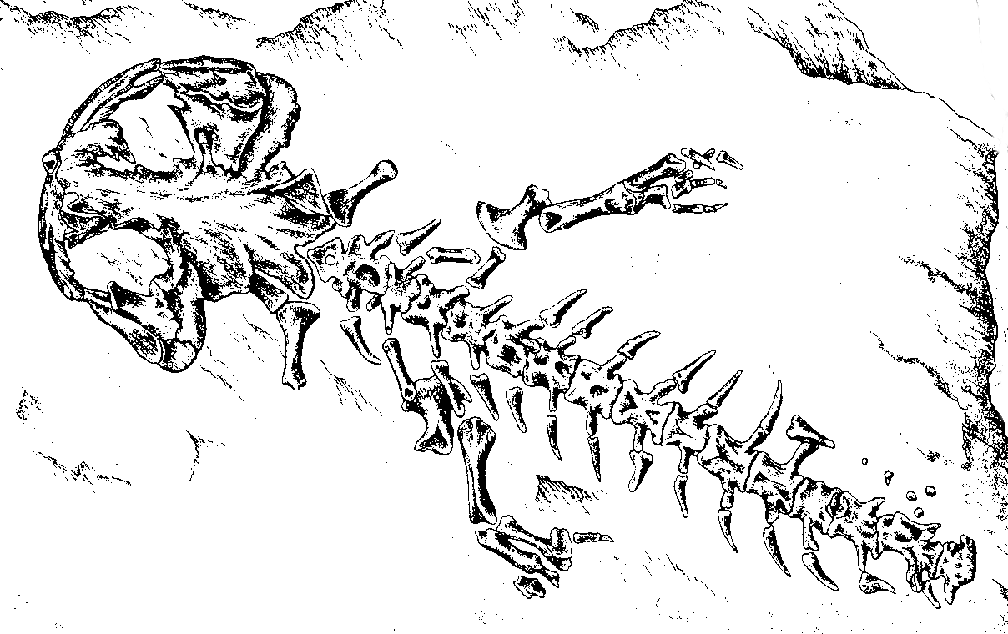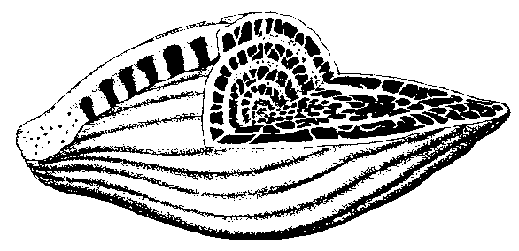

May 3-6 Arthropods.
· [Prothero, Ch. 14; Feldmann, Ch. 8-10.]
LAB 6: Arthropods.

May 9-13 Arthropods (continued). Echinoderms.
· [Prothero, Ch. 16; Feldmann, Ch. 17.]
LAB 7: Echinoderms.

May 16-20 Trace fossils; paleoecology.
· [Prothero, Ch. 18; 8; Feldmann, Ch. 25.]
LAB 8: Trace fossils and miscellaneous animals.

May 23-27 Vertebrates and their relatives.
· [Prothero, Ch. 17; 9-10; Feldmann, Ch. 18-19, 21.]
LAB 9: Vertebrates and their relatives.

May 30 No class (Memorial Day)
May 31- Vertebrates (continued); terrestrial plants.
June 3 · [Prothero, Ch. 19; Feldmann, Ch. 22-23.]
LAB 10: Terrestrial plants.

June 8 (W) FINAL EXAM (Comprehensive), 11:30 a.m.- 1:18 p.m.

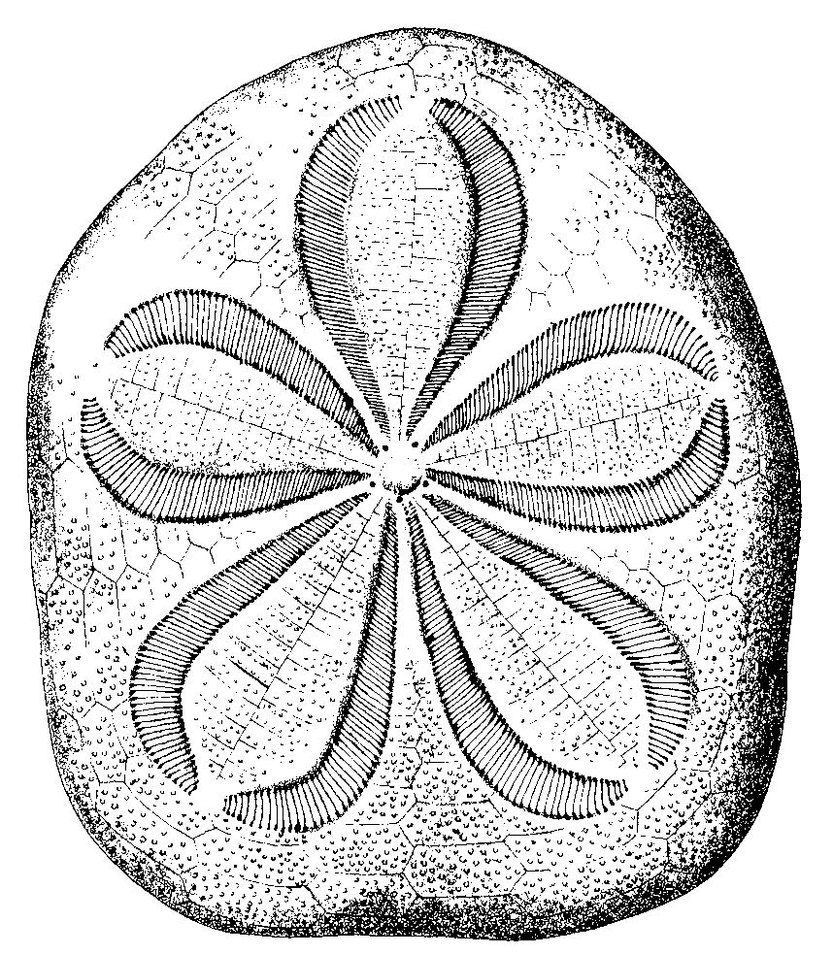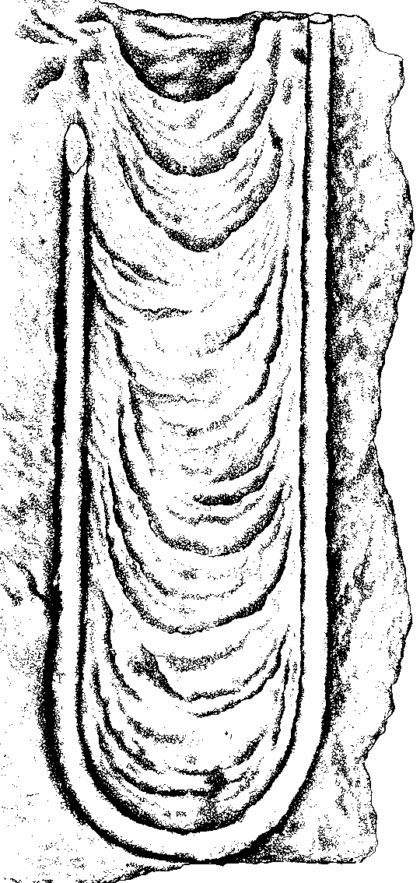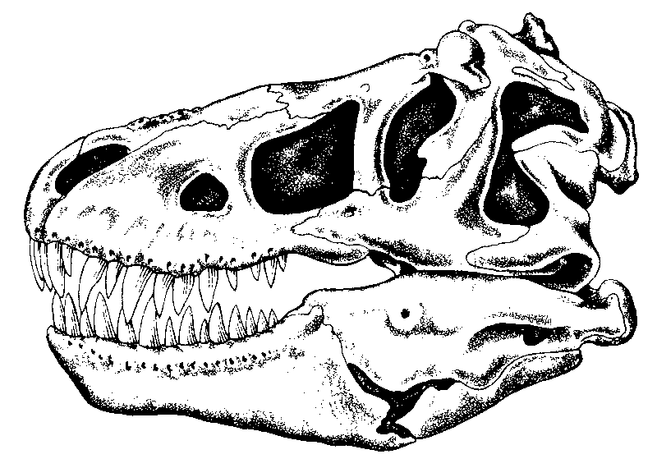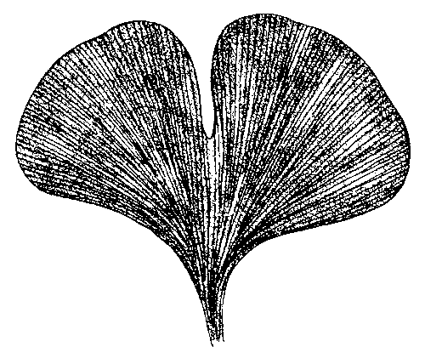

COURSE OBJECTIVES:
- To develop an understanding of Earth’s biotic history and evolution through geologic time.
- To develop an understanding of the processes that have helped shape the fossil record.
- To develop an understanding of some major tools and techniques used to interpret Earth’s biotic history and evolution.
- To develop an understanding of the application of paleontological information in the Earth and biological sciences.

ATTENDANCE:
- Lecture and lab attendance is expected. This is a fast-paced course in which a considerable amount of information is covered. You are responsible for all material covered in the lectures and laboratories that you miss due to illness, etc.

EXAMS, FIELD TRIP, AND GRADES:
- One midterm exam and one comprehensive final exam will be given. Lecture and lab material is integrated closely, and exams will cover information from both the lecture and lab parts of the course. Material from the textbooks is important for both lecture and lab, but exams will not cover material from the textbooks that has not been covered in either lecture or lab. The lab grade will be based on ten lab exercises.
- A field trip to a richly fossiliferous site constitutes part of the course. You will assemble a small collection of fossils, and identify taxa present in the collection. If for some reason you are unable to complete the field collection part of the course, the instructor will provide you with a set of specimens that you will identify.
- Final grades will be calculated as follows:
Exam 1 = 35%
Final exam = 40%
Lab = 20%
Fossil ID = 5%

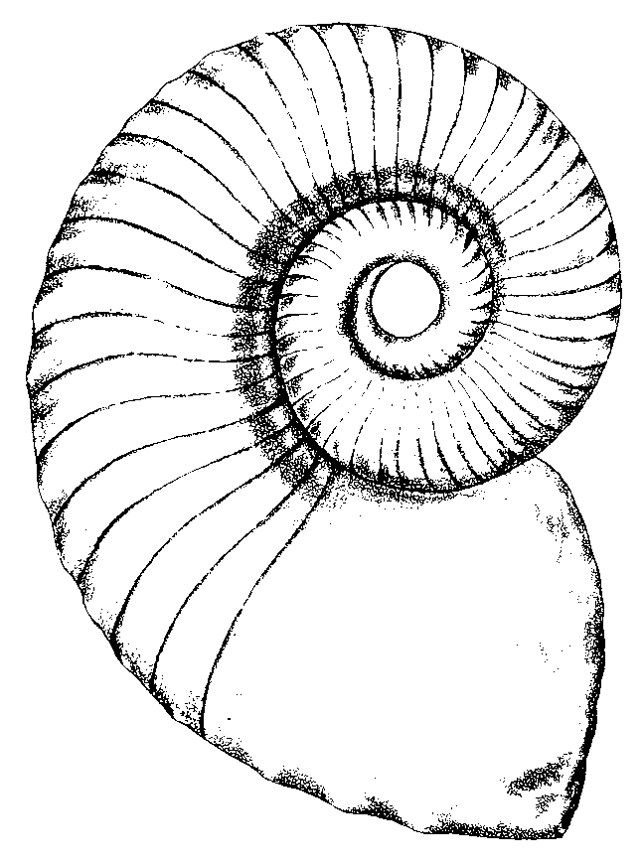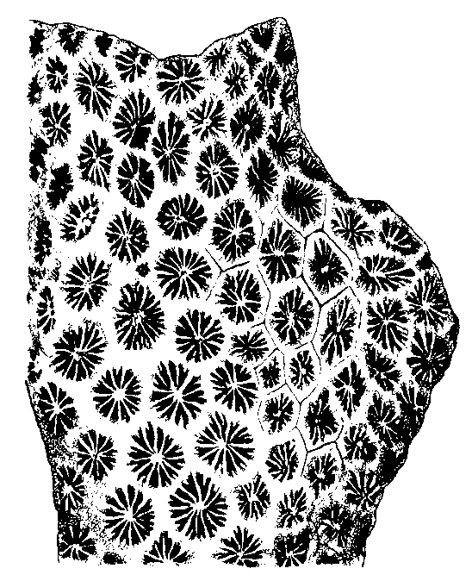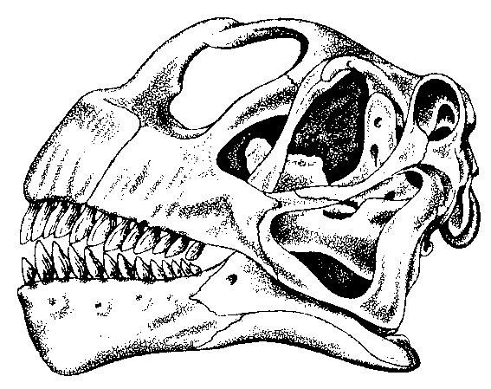
GEOLOGIC TIME SCALE (2004)

PHANEROZOIC

CENOZOIC

MESOZOIC

PALEOZOIC

Carbon-

iferous

PROTEROZOIC

ARCHEAN

"Precambrian"
ERAS
PERIODS
EONS
EPOCHS
HOLOCENE
PLEISTOCENE
PLIOCENE
MIOCENE
OLIGOCENE
EOCENE
PALEOCENE

NEOGENE

PALEOGENE

CRETACEOUS

JURASSIC

TRIASSIC
PERMIAN
PENNSYLVANIAN
MISSISSIPPIAN
DEVONIAN
SILURIAN
ORDOVICIAN
CAMBRIAN

AGES

(Ma)

0.01

1.8

5.3

23.0

33.9

55.8

65.5

146

200

251

299

318

359

416

444

488

542

2500

~4550

